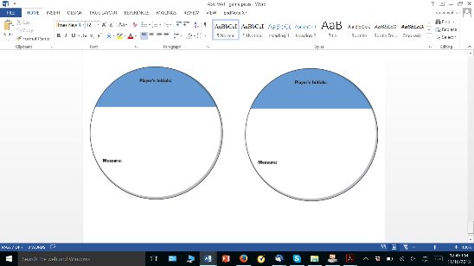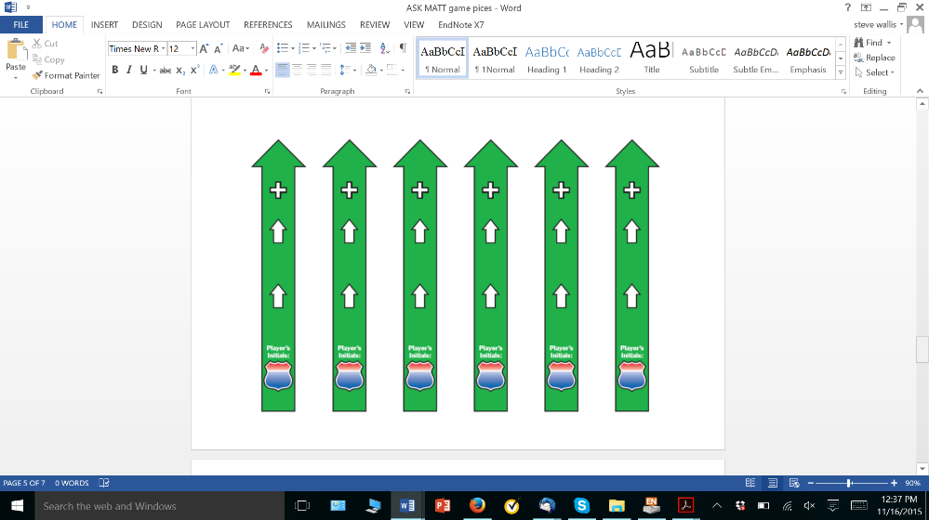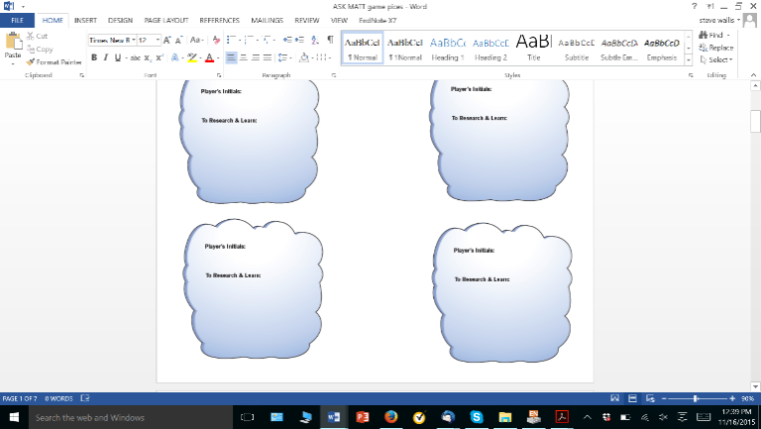

***STRATEGIC KNOWLEDGE MAPPING***

**This Fun and Easy Game is the Perfect Companion to**

**Your Strategic Planning Process**

Play this game to make difficult strategic decisions with greater confidence and achieve more reliable success!

***No Batteries Required - Powered by Human Ingenuity!***

[**http://meaningfulevidence.com**](http://meaningfulevidence.com)

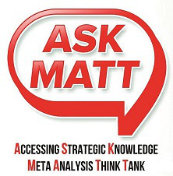

ASK MATT is a game designed to help members of organizations and coalitions to better understand their operating environment to achieve greater success.

As the game is played, bits of information held by individuals are linked into a more coherent map – a map that is more useful for guiding organizations and making key strategic decisions with greater confidence. And… it is fun!

**SOME GENERAL STUFF**

Players

The game is best when played with four to six people. If players are not familiar with the game, or if there are many people playing, it is recommended that the organization should recruit a certified ASK MATT coach — someone who is not playing the game, but is familiar with the game process and responsible for making sure the game runs smoothly. If many players are involved, it may also be useful to play the game with multiple smaller groups – and then integrate the maps later on.

Equipment

This game includes five pieces (*POIs, Causeways, FOG, Gold Stars,* and *Blue Ribbons*). There are also score sheets (for tracking progress), marker pens (for writing information on pieces). A two-minute timer is used for moderating conversations. The playing surface provides a place to place the pieces. The Game may also be played on a table-top or any other surface where the pieces may be set. Because players may want to save and/or move the MAP, it is often useful to play on some large sheets of chart-paper or butcher-paper. That way, the map may be rolled up your map and carried to meetings (the MAP may also be moved and connected with other MAPs).

Scoring (overview)

**Individuals** gain higher scores by placing *Causeways* and *POIs*.The **Group** gains higher scores by having a MAP that is more complex and more interconnected (which, for a map, makes it more practical and useful for navigation). In this game, in a sense, each player is competing with other players to gain a higher score. That scoring sets a tone of friendly competition where each individual is striving to bring out the best knowledge in themselves and each other. The idea is not to reduce the score of others. Because, at the same time, all players are working together to gain a higher Group score – more like a running race, than a football game. That scoring reflects a quest for greater shared understanding of the world.

**Tweet about your journey, discovery, and emerging map at: #MATTMAPS**

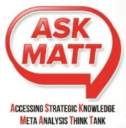

**DETAILS, HINTS, & STRATEGIES**

A“P*oint Of Interest*”(POI) – is like a place on a map. Players chooses what their *POI* will be and writes a title on the piece. Instead of “national parks” this can be anything that the player feels is important or interesting for the organization – from “pencils in the stockroom,” to “employee motivation,” and even “interest rate.” POIs should be measurable – but it is not absolutely essential. After all, there are some very important things in life that are very difficult to quantify.

A “*Causeway*” is like a road on a map. Only here, *Causeways* show the direction of cause-and-effect. For example, one *POI* might say, “providing more customer service training for employees” and a *Causeway* is played to link the training with another *POI* “customers more satisfied.” Essentially, the causeway tells how changes in on *POI* results in changes in another *POI*. A good way to evaluate a Causeway is to listen to how it sounds in a sentence. For example, “More of (this *POI*) will cause more of (that *POI)*.” Negative expressions are not allowed. It is silly to say “This does NOT cause that” or “You can’t get there from here.”

A “*Fog*” is placed when the group cannot come to a fast voting decision. *Fog* indicates lack of group clarity and the need for additional research. A *Fog* is placed if there is no majority for a vote on the measurability of a *POI* or the validity of a *Causeway*… or by group majority if the argument gets too heated (we’ve all been on road trips like that). When this occurs, discussion on the piece is halted for the time and play continues to the next person. A *Causeway* that is under FOG may remain on the map but does not count toward any player’s point total. A POI under FOG may remain on the table but the player does not receive a bonus point for measurability.

BONUS - A *Gold Star* is placed on a *POI* the first time that a second valid *Causeway* is placed pointing **towards** the POI (a valid Causeway is one that passes the vote). The player who places that *Causeway* is awarded a **bonus point**. On a real map, different roads provide you with different options for reaching your destinations. The *Gold Star* shows the importance of having different paths to reach your *POIs*. MORE POIs with Gold Stars means a higher **Group** score.

BIG BONUS - When a player places a valid *Causeway* that completes a beltway, the player is awarded five points. A beltway is a loop which includes four or more *POIs*, with all the *Causeways* between the POIs pointing in the “same” direction (so a vehicle could travel in a loop back to its starting point without violating any traffic laws). The Blue Ribbon shows the importance of recognizing positive and negative reinforcing loops (also called virtuous cycles and vicious cycles).

TO GAIN a higher score, be sure that the POIs you play are measurable. Some things (morale, for example) are important, but not easily measurable. Be sure that the Causeways you play are reasonable! Finally, aim to be the person who places the second Causeway pointing toward a POI.

**MISCELLANEOUS RULES**

* Pieces may be rearranged by group consensus – especially to make the map more readable and/or to make room for more pieces.
* A “FOG” piece may be placed by any person as a reminder to indicate where additional conversation or research is needed “outside the room.” No adjustment to score occurs when a *Fog* is placed by an individual.
* Rules may be changed with consent of facilitator and consensus of all players. All changes must be reviewed monthly to see if they are helping or hindering improvement.

***Player’s***

***Initials:***

***POI***

***CAUSEWAY***

***Player’s***

***Initials***



***Points***



ASKMATT Basic Game: Rules of the Road

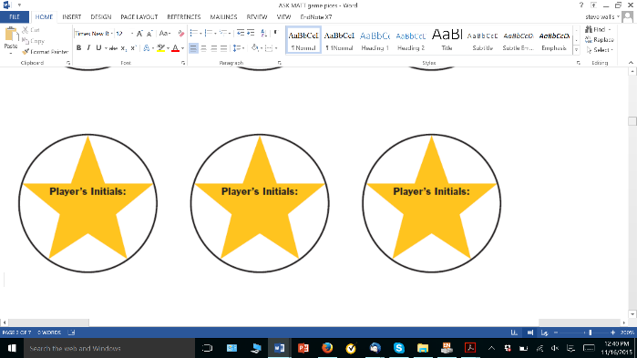

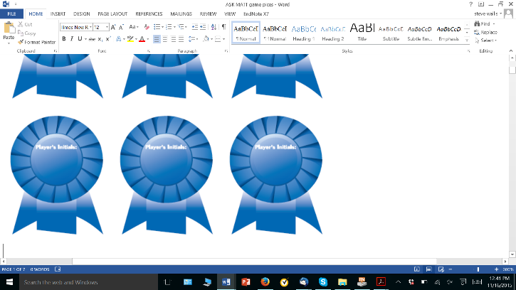

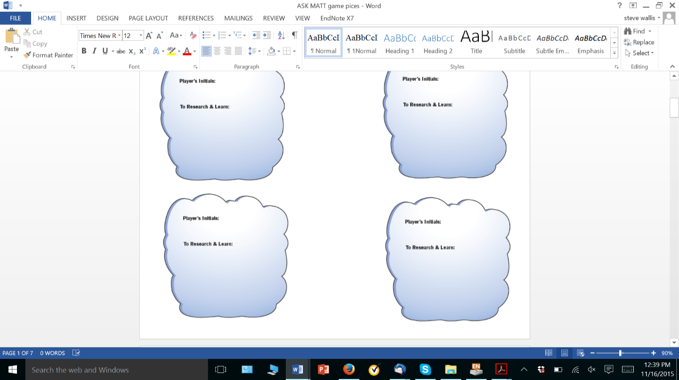

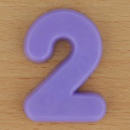

START HERE

1. **When the piece is played, all players VOTE (majority rules)**
2. If the piece is a *POI*, the group votes on the question **“Is it measurable?”** Conversation is encouraged within a two-minute time limit.
   * 1. **YES?** Give the player two points!
     2. **NO?** Give the player one point.
     3. **MAYBE? –** If the group cannot agree, no point is given. Place a “FOG” piece on the POI to indicate that further discussion and research is needed.
3. If the piece is a *Causeway*, the group votes on the question, **“Is it a reasonable or sensible connection?”** Conversation is encouraged within a two-minute time limit.
   * 1. **YES?** Give the player one point!
     2. **NO?** Remove the Causeway from the MAP – no point given.
     3. **MAYBE?** (or TIE VOTE) – leave the Causeway on the MAP, and place a FOG piece on the road to indicate that further research and conversation is needed – no point is awarded.

**Before the game starts…**

* Write the players’ names on the score sheet.
* Decide on the focus of the Game based on the topic that the Group wishes to explore.
* Write that focus as the title for the MAP. For example, “XYZ Company’s Map for Marketing” or “Relationships in the Health Care Coalition of ABC County.”
* Choose a person to be the timekeeper – don’t argue for more than two minutes over anything!
* Select one person to the Scorekeeper – make sure he or she has a calculator. The Scorekeeper goes first… play follows around the table clockwise.

**GAME PLAY**



1. **The first player places a game piece on the MAP.**

The piece may be a *Causeway or a Point of Interest (POI)*.

1. If the piece is a *POI*, the player must write what the *POI* represents (such as “special marketing efforts” or “monthly income”).

AND, the player must write how it is measured (e.g. “sales junkets” or “dollars in accounts receivable”)

1. If the piece played is a *Causeway*, it must be placed to show a link between two *POIs.*

*AND* the player must mark the head of the arrow with a “+” or a “–“ (or write in the appropriate word) to show how changes in one *POI* causes the level of the other *POI* to become “more” or “less.” For example, showing how “special marketing efforts” cause increases in “income.”

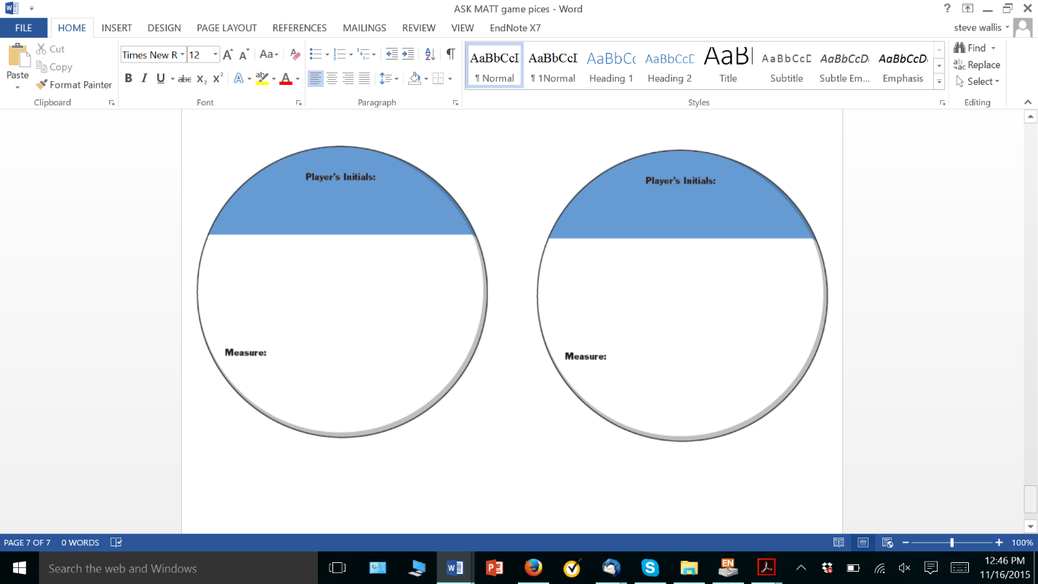

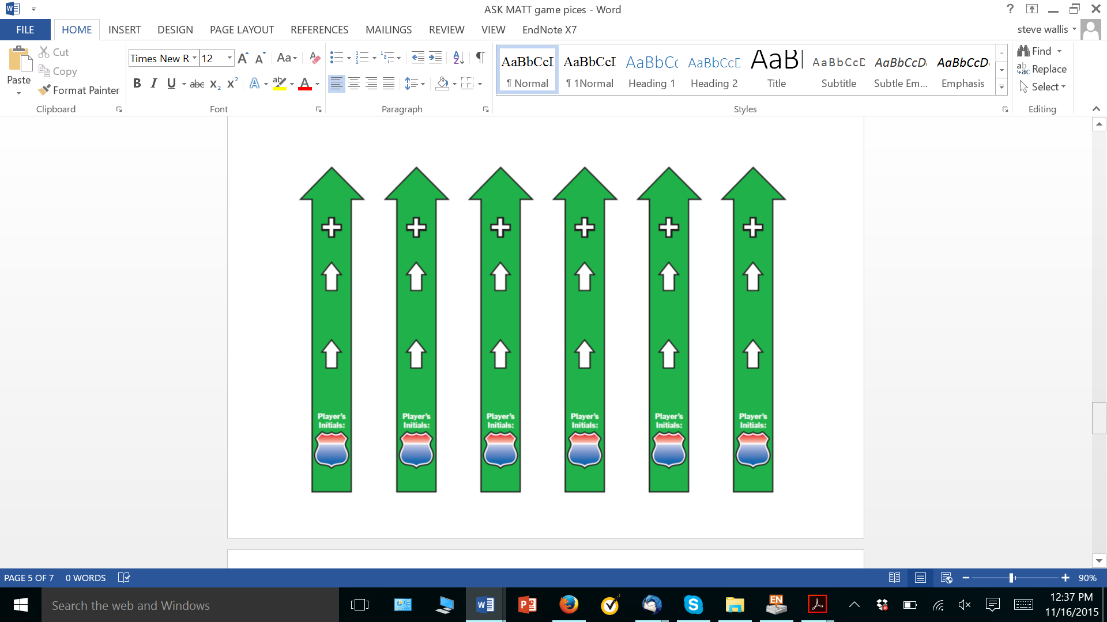****

1. **The Scorekeeper records points as they are voted/awarded.**

**AFTER THE GAME – The road goes on…**

While you may be tempted to play the Game “until the cows come home,” it may be more useful to put the game on “pause” and resume playing another day. It is also useful to schedule some time at the end of the game (at least 30 minutes) to have a general conversation about the Game. You might discuss:

* What did you learn from the Game?
* What “blind spot” exists because a POI does not have a gold star?
* What concepts and connections and loops might be added to the MAP?
* What new insights might be emerging that suggest new strategies & plans?
* What are some implications for managing the organization and tracking progress?
* What “leverage points” might exist for change – where one improvement will cascade into many?
* How might you merge multiple maps?
* What are these cows doing here?
* Seriously, the game continues as you play the “Long Game” – the ***Road Trip***

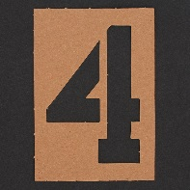

1. **AND – play passes to the next player to place a piece.**

**TEAM SCORE** – when all players have taken a turn and placed a piece and the individual voting has been done, ONE ROUND has been completed. The scorekeeper calculates the team score and records the information on the ScoreSheet.

**THE GAME ENDS** – when the cows come home, when an overweight female croons a tune, or if you have run out of room on the ScoreSheet or the playing surface.